The Giving Tree
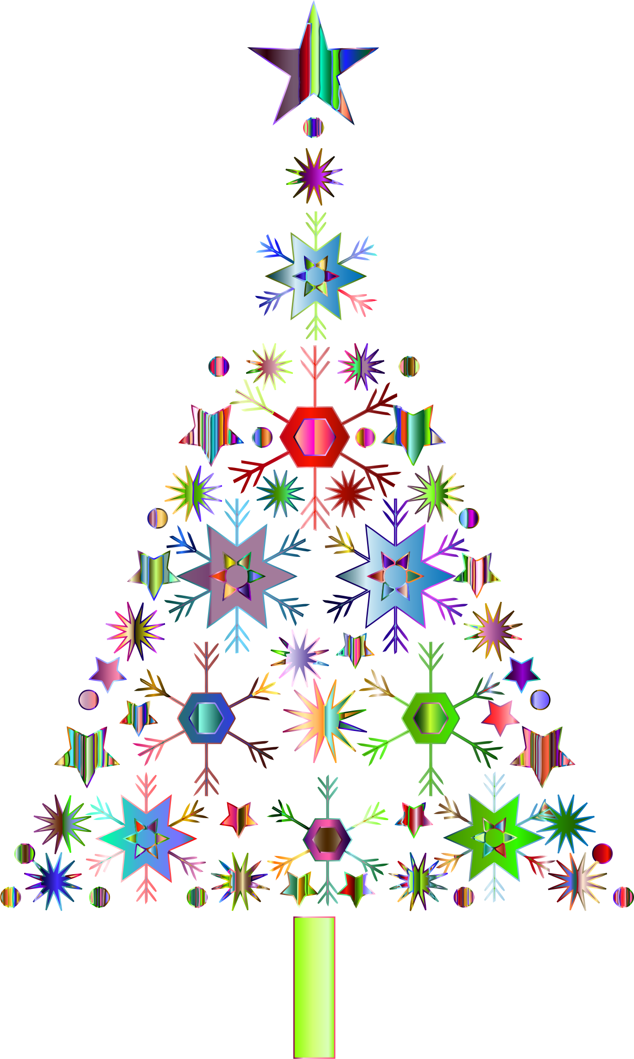
Please help students in our community

Please select a snowflake from the giving tree in the BFA Fairfax
Middle/High School main office.

All gifts need to be returned by December 11.

